Title
Firstname Lastname ¹, Firstname Lastname ² and Firstname Lastname ^{2,}*
¹ Affiliation 1; e-mail@e-mail.com
² Affiliation 2; e-mail@e-mail.com
* Correspondence: e-mail@e-mail.com; Tel.: (optional; include country code; if there are multiple corresponding authors, add author initials)
Abstract: A single paragraph of about 200 words maximum. For research articles, abstracts should give a pertinent overview of the work. We strongly encourage authors to use the following style of structured abstracts, but without headings: (1) Background: Place the question addressed in a broad context and highlight the purpose of the study; (2) Methods: briefly describe the main methods or treatments applied; (3) Results: summarize the article’s main findings; (4) Conclusions: indicate the main conclusions or interpretations. The abstract should be an objective representation of the article and it must not contain results that are not presented and substantiated in the main text and should not exaggerate the main conclusions.
Keywords: keyword 1; keyword 2; keyword 3 (List three to ten pertinent keywords specific to the article yet reasonably common within the subject discipline.)

1. Introduction
The introduction should briefly place the study in a broad context and highlight why it is important. It should define the purpose of the work and its significance. The current state of the research field should be carefully reviewed and key publications cited. Please highlight controversial and diverging hypotheses when necessary. Finally, briefly mention the main aim of the work and highlight the principal conclusions. As far as possible, please keep the introduction comprehensible to scientists outside your particular field of research. References should be numbered in order of appearance and indicated by a numeral or numerals in square brackets—e.g., [1] or [2,3], or [4–6]. See the end of the document for further details on references.

2. Materials and Methods
The Materials and Methods should be described with sufficient details to allow others to replicate and build on the published results. Please note that the publication of your manuscript implicates that you must make all materials, data, computer code, and protocols associated with the publication available to readers. Please disclose at the submission stage any restrictions on the availability of materials or information. New methods and protocols should be described in detail while well-established methods can be briefly described and appropriately cited.
Research manuscripts reporting large datasets that are deposited in a publicly available database should specify where the data have been deposited and provide the relevant accession numbers. If the accession numbers have not yet been obtained at the time of submission, please state that they will be provided during review. They must be provided prior to publication.
Interventionary studies involving animals or humans, and other studies that require ethical approval, must list the authority that provided approval and the corresponding ethical approval code.

3. Results
This section may be divided by subheadings. It should provide a concise and precise description of the experimental results, their interpretation, as well as the experimental conclusions that can be drawn.

3.1. Subsection

3.1.1. Subsubsection
The text continues here.

3.2. Figures, Tables and Schemes
All figures and tables should be cited in the main text as Figure 1, Table 1, etc.
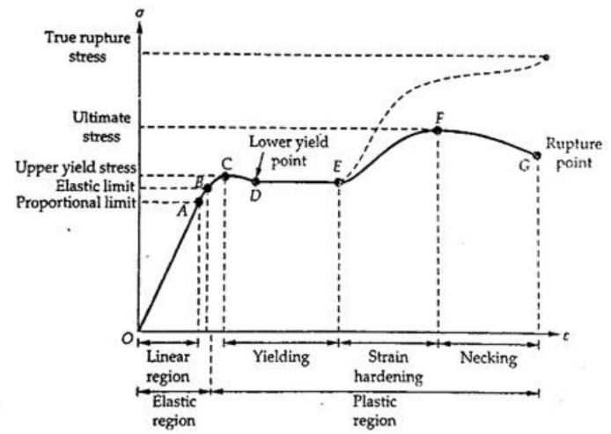
Figure 1. This is a figure. Schemes follow the same formatting.
Table 1. This is a table. Tables should be placed in the main text near to the first time they are cited.
Title 1 | Title 2 | Title 3
entry 1 | data | data
entry 2 | data | data ¹
¹ Tables may have a footer.
The text continues here (Figure 2 and Table 2).
(a) | (b)
Figure 2. This is a figure. Schemes follow another format. If there are multiple panels, they should be listed as: (a) Description of what is contained in the first panel; (b) Description of what is contained in the second panel. Figures should be placed in the main text near to the first time they are cited.

Table 2. This is a table. Tables should be placed in the main text near to the first time they are cited.
Title 1 | Title 2 | Title 3 | Title 4
entry 1 * | data | data | data
 | data | data | data
 | data | data | data
entry 2 | data | data | data
 | data | data | data
entry 3 | data | data | data
 | data | data | data
 | data | data | data
 | data | data | data
entry 4 | data | data | data
 | data | data | data
* Tables may have a footer.

3.3. Formatting of Mathematical Components
This is example 1 of an equation:
a = 1, | (1)
the text following an equation need not be a new paragraph. Please punctuate equations as regular text.
This is example 2 of an equation:
a = b + c + d + e + f + g + h + i + j + k + l + m + n + o + p + q + r + s + t + u + v + w + x + y + z | (2)
the text following an equation need not be a new paragraph. Please punctuate equations as regular text.
Theorem-type environments (including propositions, lemmas, corollaries etc.) can be formatted as follows:
Theorem 1. Example text of a theorem. Theorems, propositions, lemmas, etc. should be numbered sequentially (i.e., Proposition 2 follows Theorem 1). Examples or Remarks use the same formatting, but should be numbered separately, so a document may contain Theorem 1, Remark 1 and Example 1.
The text continues here. Proofs must be formatted as follows:
Proof of Theorem 1. Text of the proof. Note that the phrase “of Theorem 1” is optional if it is clear which theorem is being referred to. Always finish a proof with the following symbol. □
The text continues here.

4. Discussion
Authors should discuss the results and how they can be interpreted from the perspective of previous studies and of the working hypotheses. The findings and their implications should be discussed in the broadest context possible. Future research directions may also be highlighted.

5. Conclusions
This section is not mandatory but can be added to the manuscript if the discussion is unusually long or complex.

6. Patents
This section is not mandatory but may be added if there are patents resulting from the work reported in this manuscript.
Supplementary Materials: The following supporting information can be downloaded at: www.iiicell.com/xxx/s1, Figure S1: title; Table S1: title; Video S1: title.
Funding: Please add: “This research received no external funding” or “This research was funded by NAME OF FUNDER, grant number XXX” and “The APC was funded by XXX”. Check carefully that the details given are accurate and use the standard spelling of funding agency names at https://search.crossref.org/funding. Any errors may affect your future funding.
Acknowledgments: In this section, you can acknowledge any support given which is not covered by the author contribution or funding sections. This may include administrative and technical support, or donations in kind (e.g., materials used for experiments).
Appendix A
The appendix is an optional section that can contain details and data supplemental to the main text—for example, explanations of experimental details that would disrupt the flow of the main text but nonetheless remain crucial to understanding and reproducing the research shown; figures of replicates for experiments of which representative data is shown in the main text can be added here if brief, or as Supplementary data. Mathematical proofs of results not central to the paper can be added as an appendix.
Appendix B
All appendix sections must be cited in the main text. In the appendices, Figures, Tables, etc. should be labeled starting with “A”—e.g., Figure A1, Figure A2, etc.

References
References must be numbered in order of appearance in the text (including citations in tables and legends) and listed individually at the end of the manuscript. We recommend preparing the references with a bibliography software package, such as EndNote, ReferenceManager or Zotero to avoid typing mistakes and duplicated references. Include the digital object identifier (DOI) for all references where available.

Citations and references in the Supplementary Materials are permitted provided that they also appear in the reference list here.

In the text, reference numbers should be placed in square brackets [ ] and placed before the punctuation; for example [1], [1–3] or [1,3]. For embedded citations in the text with pagination, use both parentheses and brackets to indicate the reference number and page numbers; for example [5] (p. 10), or [6] (pp. 101–105).

- Author 1, A.B.; Author 2, C.D. Title of the article. Abbreviated Journal Name Year, Volume, page range.
- Author 1, A.; Author 2, B. Title of the chapter. In Book Title, 2nd ed.; Editor 1, A., Editor 2, B., Eds.; Publisher: Publisher Location, Country, 2007; Volume 3, pp. 154–196.
- Author 1, A.; Author 2, B. Book Title, 3rd ed.; Publisher: Publisher Location, Country, 2008; pp. 154–196.
- Author 1, A.B.; Author 2, C. Title of Unpublished Work. Abbreviated Journal Name year, phrase indicating stage of publication (submitted; accepted; in press).
- Author 1, A.B. (University, City, State, Country); Author 2, C. (Institute, City, State, Country). Personal communication, 2012.
- Author 1, A.B.; Author 2, C.D.; Author 3, E.F. Title of Presentation. In Proceedings of the Name of the Conference, Location of Conference, Country, Date of Conference (Day Month Year).
- Author 1, A.B. Title of Thesis. Level of Thesis, Degree-Granting University, Location of University, Date of Completion.
- Title of Site. Available online: URL (accessed on Day Month Year).

